Week 3
1.
import java.io.*;
import java.util.*;

public class Solution {

public static String findDay(int month, int day, int year) {
Calendar cal = Calendar.getInstance();
cal.set(year, month - 1, day);

String[] days = {
"SUNDAY",
"MONDAY",
"TUESDAY",
"WEDNESDAY",
"THURSDAY",
"FRIDAY",
"SATURDAY"
};

return days[cal.get(Calendar.DAY_OF_WEEK) - 1];
}

public static void main(String[] args) {
Scanner sc = new Scanner(System.in);

int month = sc.nextInt();
int day = sc.nextInt();
int year = sc.nextInt();

System.out.println(findDay(month, day, year));

sc.close();
}
}

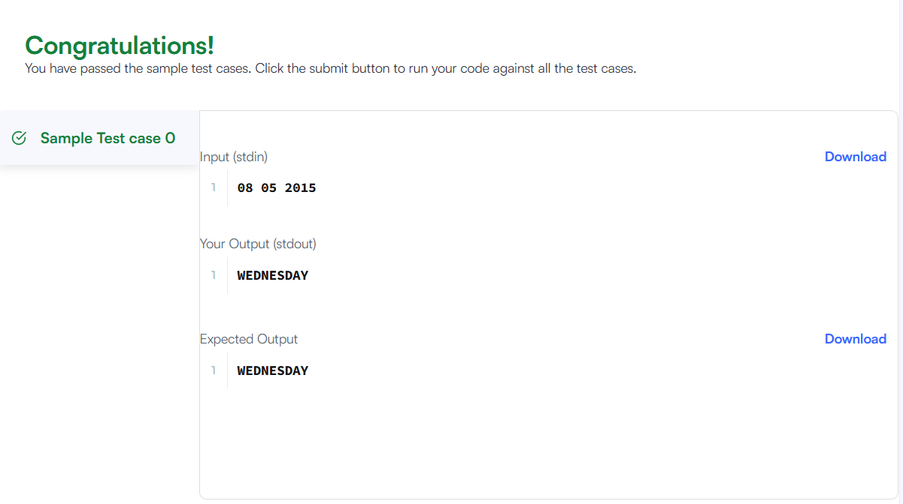
2.)
import java.time.LocalDate;
import java.time.temporal.ChronoUnit;

class Solution {
public int daysBetweenDates(String date1, String date2) {
// Parse the string dates into LocalDate objects
LocalDate d1 = LocalDate.parse(date1);
LocalDate d2 = LocalDate.parse(date2);

// Calculate the absolute difference in days between the two dates
return (int) Math.abs(ChronoUnit.DAYS.between(d1, d2));
}
}

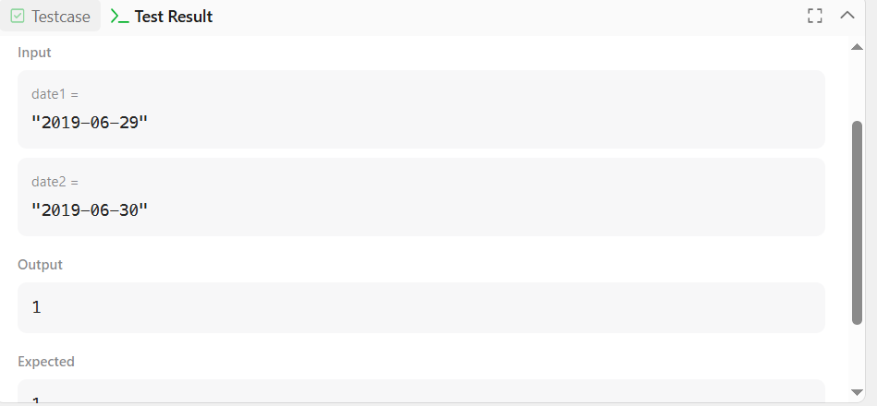
3.)
import java.time.LocalDate;

class Solution {
public int dayOfYear(String date) {
// Parse the string into a LocalDate object
LocalDate d = LocalDate.parse(date);

// Return the day of the year directly
return d.getDayOfYear();
}
}

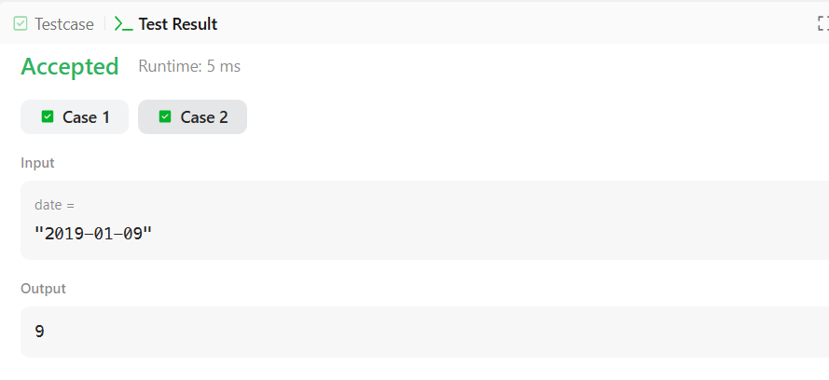
4.)
import java.util.ArrayList;
import java.util.List;
import java.util.Scanner;
import java.util.PriorityQueue;
import java.util.Comparator;

class Student {
private int id;
private String name;
private double cgpa;

public Student(int id, String name, double cgpa) {
this.id = id;
this.name = name;
this.cgpa = cgpa;
}

public int getID() {
return id;
}

public String getName() {
return name;
}

public double getCGPA() {
return cgpa;
}
}

class Priorities {
public List<Student> getStudents(List<String> events) {
PriorityQueue<Student> pq = new PriorityQueue<>(
Comparator.comparing(Student::getCGPA, Comparator.reverseOrder())
.thenComparing(Student::getName)
.thenComparing(Student::getID)
);

for (String event : events) {
String[] parts = event.split(" ");
if (parts[0].equals("ENTER")) {
String name = parts[1];
double cgpa = Double.parseDouble(parts[2]);
int id = Integer.parseInt(parts[3]);
pq.add(new Student(id, name, cgpa));
} else if (parts[0].equals("SERVED")) {
pq.poll();
}
}

List<Student> remainingStudents = new ArrayList<>();
while (!pq.isEmpty()) {
remainingStudents.add(pq.poll());
}

return remainingStudents;
}
}

public class Solution {
private final static Scanner scan = new Scanner(System.in);
private final static Priorities priorities = new Priorities();

public static void main(String[] args) {
int totalEvents = Integer.parseInt(scan.nextLine());
List<String> events = new ArrayList<>();

while (totalEvents-- != 0) {
String event = scan.nextLine();
events.add(event);
}

List<Student> students = priorities.getStudents(events);

if (students.isEmpty()) {
System.out.println("EMPTY");
} else {
for (Student st: students) {
System.out.println(st.getName());
}
}
}
}

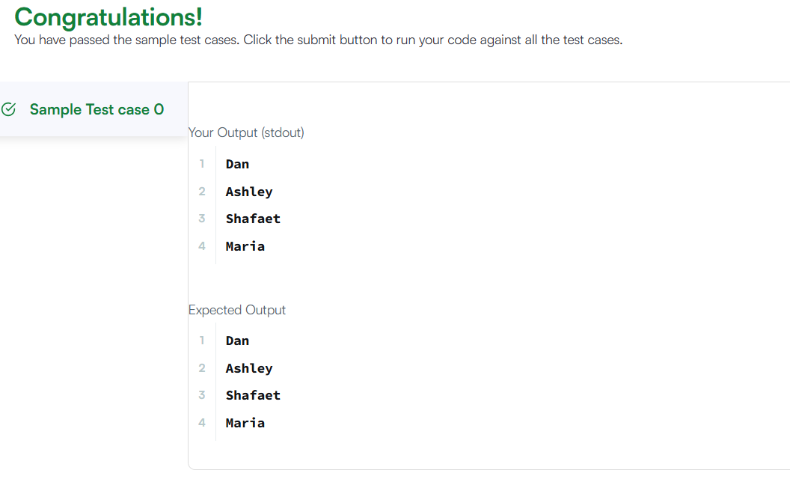
5.)
import java.io.*;
import java.util.*;

public class Solution {

public static void main(String[] args) {
Scanner scan = new Scanner(System.in);
int n = scan.nextInt();

// Create a 2D ArrayList to store the integers for each line
ArrayList<ArrayList<Integer>> lines = new ArrayList<>();

for (int i = 0; i < n; i++) {
int d = scan.nextInt();
ArrayList<Integer> row = new ArrayList<>();
for (int j = 0; j < d; j++) {
row.add(scan.nextInt());
}
lines.add(row);
}

int q = scan.nextInt();
for (int i = 0; i < q; i++) {
int x = scan.nextInt();
int y = scan.nextInt();

// Convert 1-based indices to 0-based and check bounds
if (x - 1 < lines.size() && y - 1 < lines.get(x - 1).size()) {
System.out.println(lines.get(x - 1).get(y - 1));
} else {
System.out.println("ERROR!");
}
}
scan.close();
}
}

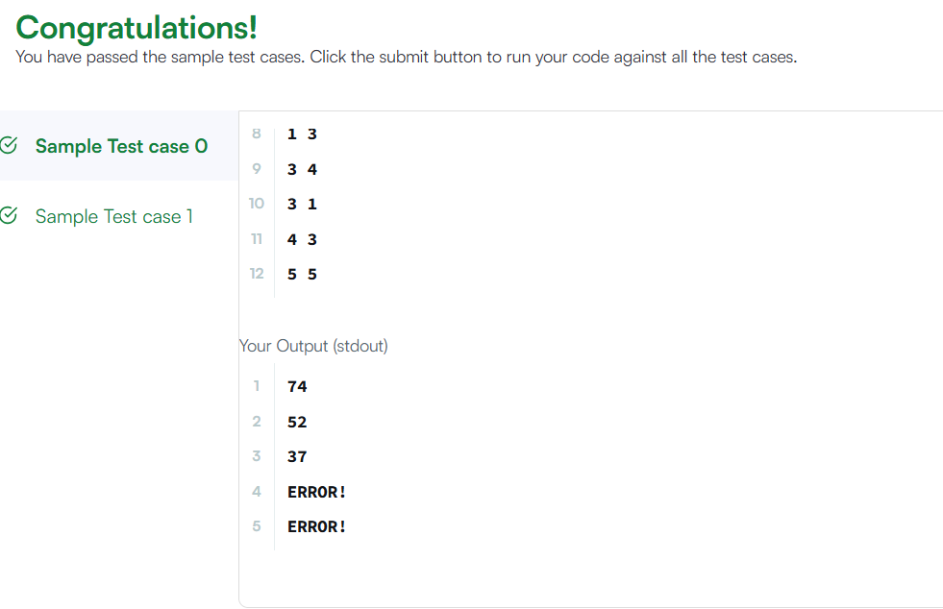
6.)
import java.util.Arrays;

class Solution {
public String largestNumber(int[] nums) {
// Convert integer array to a String array
String[] strNums = new String[nums.length];
for (int i = 0; i < nums.length; i++) {
strNums[i] = String.valueOf(nums[i]);
}

// Sort strings custom-tailored: compare (b + a) with (a + b) for descending order
Arrays.sort(strNums, (a, b) -> (b + a).compareTo(a + b));

// If the highest number is "0", the whole array consists of zeros
if (strNums[0].equals("0")) {
return "0";
}

// Concatenate all sorted strings
StringBuilder sb = new StringBuilder();
for (String s : strNums) {
sb.append(s);
}

return sb.toString();
}
}
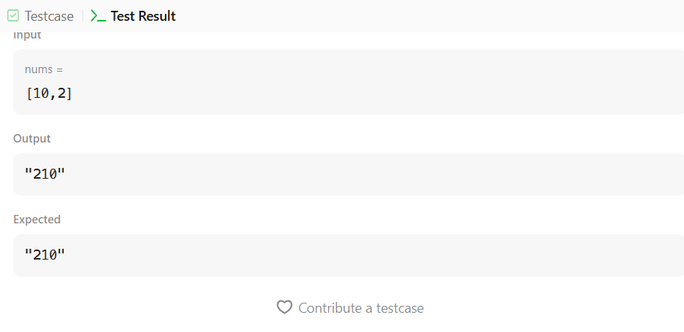
7)
import java.util.*;

class Player {
String name;
int score;

Player(String name, int score) {
this.name = name;
this.score = score;
}
}

class Checker implements Comparator<Player> {
@Override
public int compare(Player a, Player b) {
// If scores are the same, sort alphabetically by name (ascending)
if (a.score == b.score) {
return a.name.compareTo(b.name);
}
// Otherwise, sort in order of decreasing score (highest score first)
return b.score - a.score;
}
}

public class Solution {

public static void main(String[] args) {
Scanner scan = new Scanner(System.in);
int n = scan.nextInt();

Player[] player = new Player[n];
Checker checker = new Checker();

for (int i = 0; i < n; i++) {
player[i] = new Player(scan.next(), scan.nextInt());
}
scan.close();

// Sort the array using our custom Checker comparator
Arrays.sort(player, checker);

// Print the sorted players
for (int i = 0; i < player.length; i++) {
System.out.printf("%s %s\n", player[i].name, player[i].score);
}
}
}
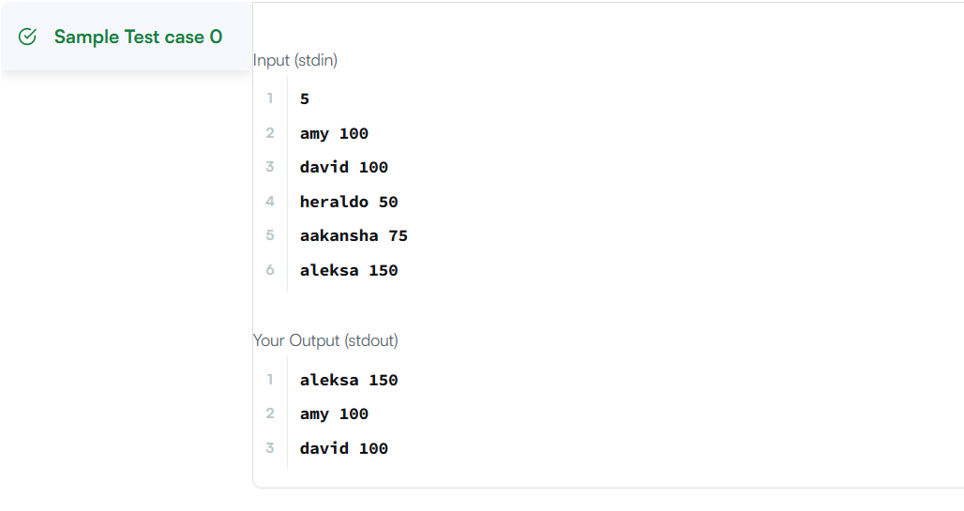
8)
import java.util.Arrays;
import java.util.Comparator;

class Solution {
public String[] sortPeople(String[] names, int[] heights) {
int n = names.length;

// Create an array of indices to sort based on heights
Integer[] indices = new Integer[n];
for (int i = 0; i < n; i++) {
indices[i] = i;
}

// Sort indices in descending order of their corresponding heights
Arrays.sort(indices, (a, b) -> Integer.compare(heights[b], heights[a]));

// Build the sorted names array using the sorted indices
String[] sortedNames = new String[n];
for (int i = 0; i < n; i++) {
sortedNames[i] = names[indices[i]];
}

return sortedNames;
}
}

